1. You are calibrating the reticle on your microscope using the 4x objective lens. On this microscope, the number of μm per reticle unit with the 4x objective is
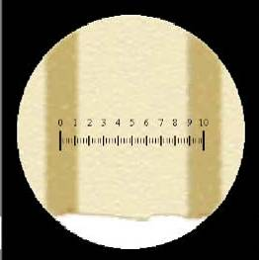

a. 0.02
b. 0.05
c. 10
*d. 20
e. 50

2. You are still using the same microscope described in Question 1. Using this
microscope, the number of μm per reticle unit with the 40x objective is

a. 0.04
b. 0.5
*c. 2
d. 10
e. 20

3. With this different microscope, each reticule unit is 2 μm. Determine the
greatest width of the organism at the tip of the red pointer.
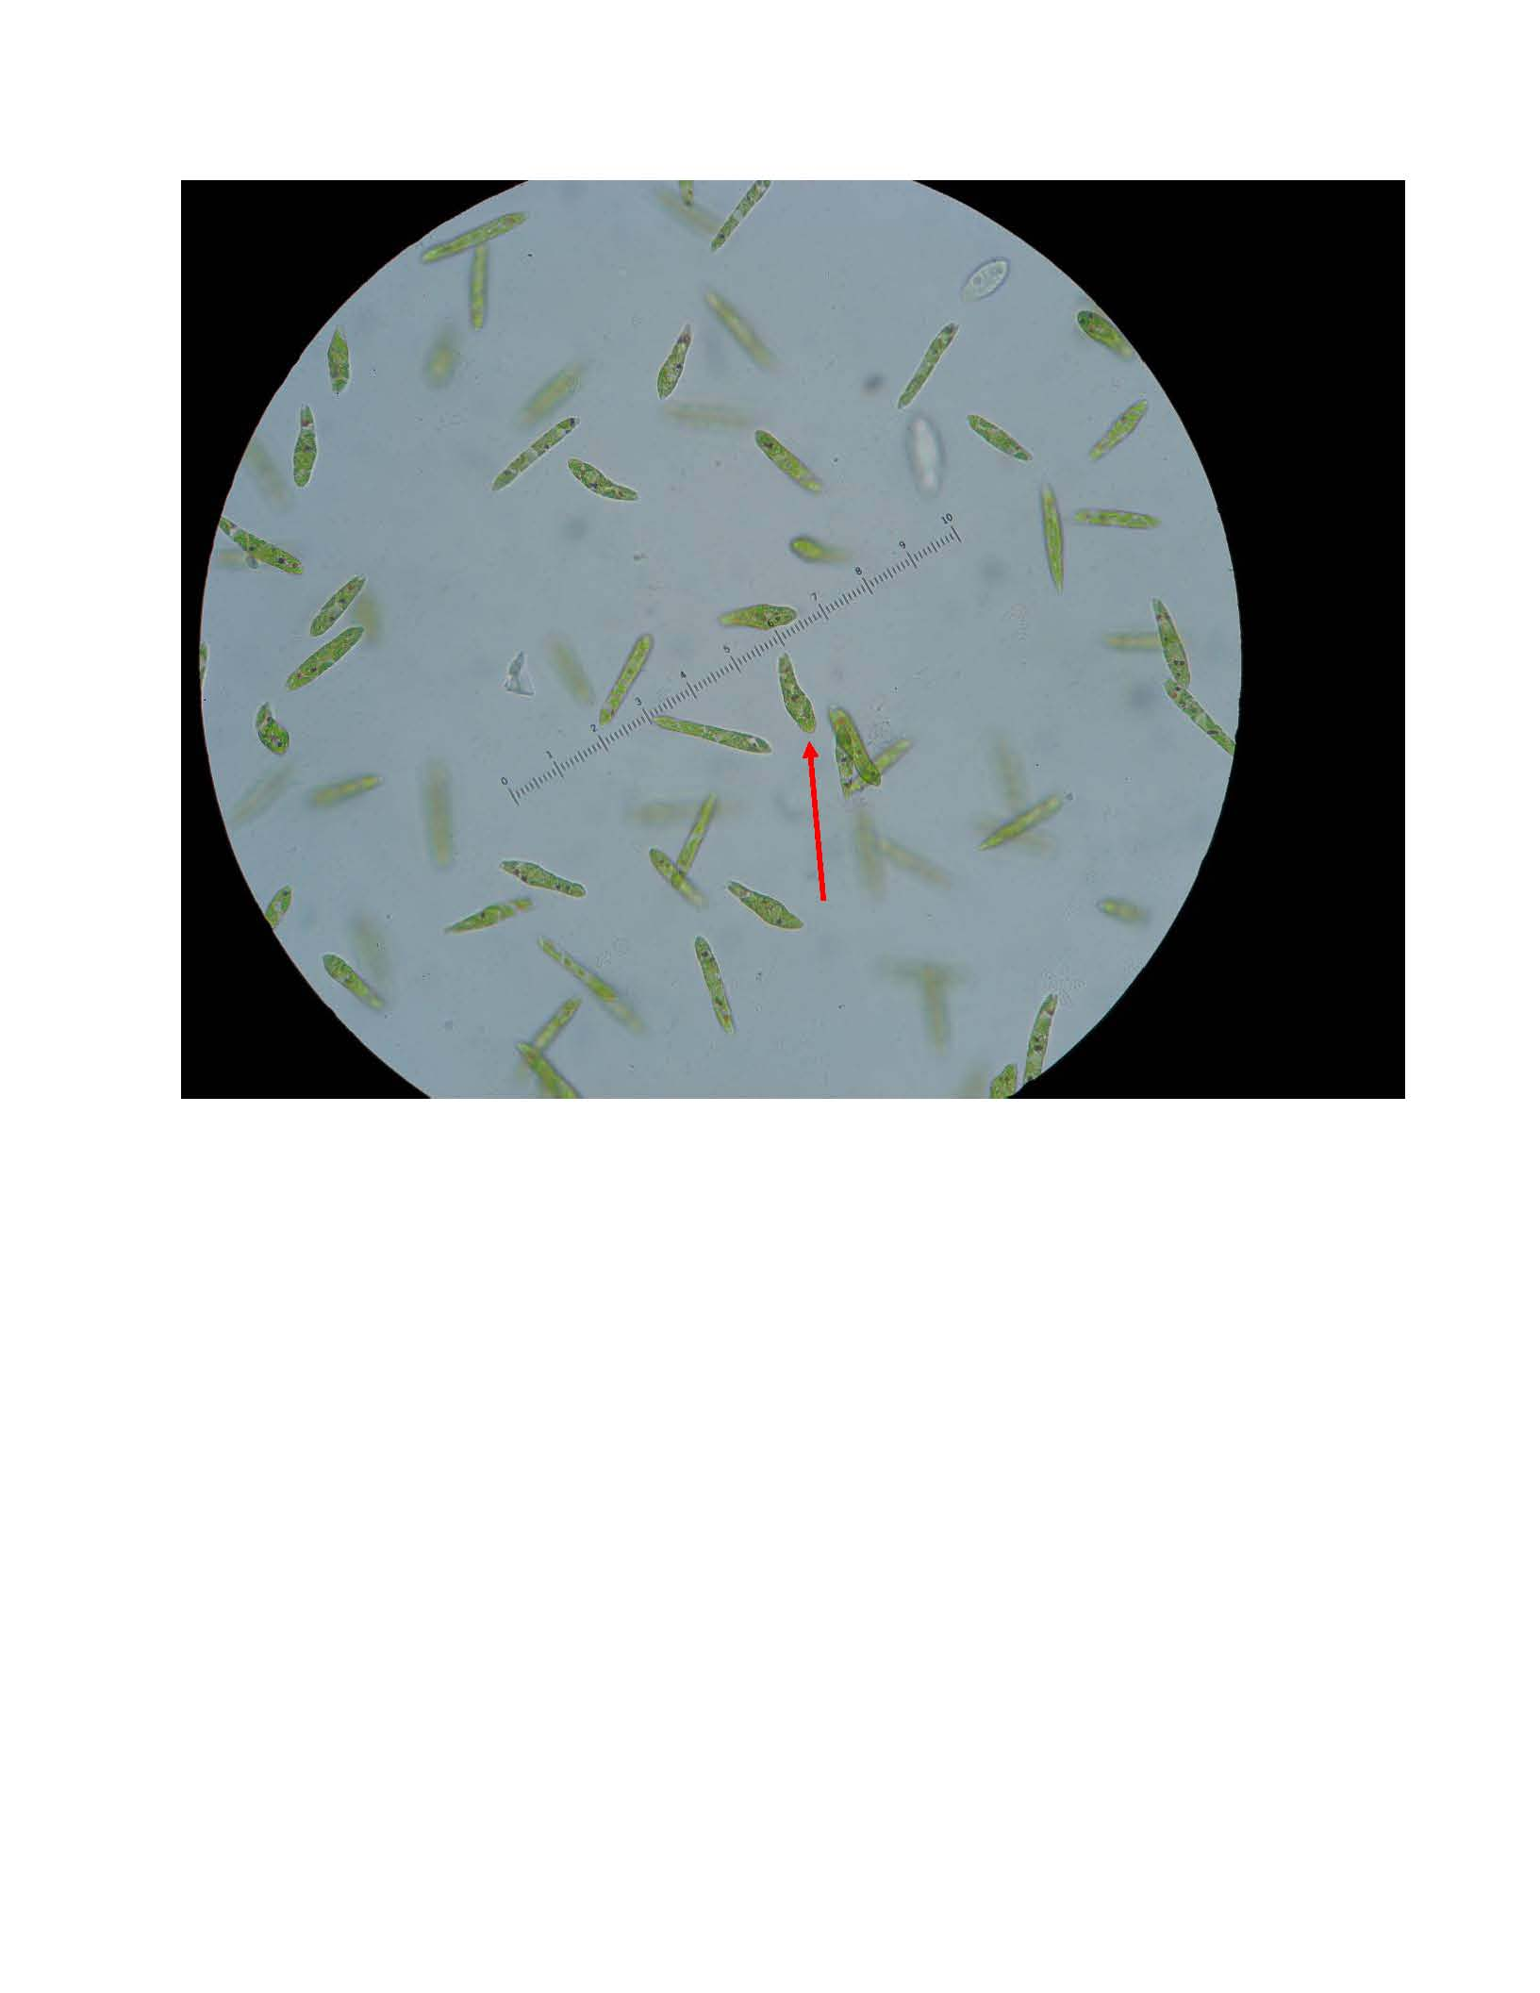

a. 2 μm
b. 4 μm
*c. 6 μm
d. 8 μm
e. 10 μm

4. If you are going to examine living microorganisms in a yogurt culture, which
technique would be most appropriate?
a. compound light microscope, using prepared slides
*b. compound light microscope, using wet mount
c. dissecting microscope
d. Vernier calipers

5. If you are going to examine the brain of a dissected earthworm without taking it
out, which technique would be most appropriate?
a. compound light microscope, using prepared slides
b. compound light microscope, using wet mount
*c. dissecting microscope
d. Vernier calipers

